SURFACE VOLUME

<___question>

Type=1

<_block>

Which of these is the volume of sphere, correct to two decimal places ?

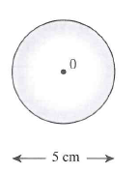

<_block>

[A] $36.82 cm³$

<_block>

[B] $65.45 cm³$

<_block>

[C] $294.52 cm³$

<_block>

[D] $523.60 cm³$

<_block>

[B]

<___question>

Type=1

<_block>

Which of these is the area of the trapezium ?

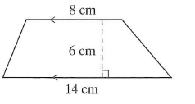

<_block>

[A] $66 cm²$

<_block>

[B] $132 cm²$

<_block>

[C] $336 cm²$

<_block>

[D] $672 cm²$

<_block>

[A]

<___question>

Type=1

<_block>

A pyramid has a volume of *300 cm³*. If the area of the base is *50 cm²* , what is its height ?

<_block>

[A] $2 cm$

<_block>

[B] $6 cm$

<_block>

[C] $18 cm$

<_block>

[D] $24 cm$

<_block>

[C]

<___question>

Type=1

<_block>

Which is closest to the area of the below figure ?

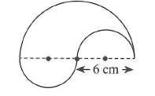

<_block>

[A] $32 cm²$

<_block>

[B] $57 cm²$

<_block>

[C] $71 cm²$

<_block>

[D] $85 cm²$

<_block>

[B]

<___question>

Type=1

<_block>

Which of these is the volume of the triangular prism ?

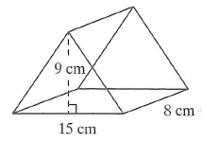

<_block>

[A] $32 cm³$

<_block>

[B] $270 cm³$

<_block>

[C] $540 cm³$

<_block>

[D] $1080 cm³$

<_block>

[C]

<___question>

Type=1

<_block>

Which of these is the surface area of the rectangular prism ?

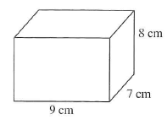

<_block>

[A] $191 cm³$

<_block>

[B] $382 cm³$

<_block>

[C] $504 cm³$

<_block>

[D] $840 cm³$

<_block>

[B]

<___question>

Type=1

<_block>

What is the volume of the square based pyramid below ?

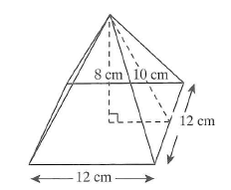

<_block>

[A] $384 cm³$

<_block>

[B] $480 cm³$

<_block>

[C] $1152 cm³$

<_block>

[D] $3840 cm³$

<_block>

[A]

<___question>

Type=1

<_block>

Which of these is the area of a triangle with base length *16 cm* and perpendicular height *10 cm* ?

<_block>

[A] $40 cm²$

<_block>

[B] $80 cm²$

<_block>

[C] $160 cm²$

<_block>

[D] $320 cm²$

<_block>

[B]

<___question>

Type=1

<_block>

Which of these is the capacity of a cube with a side length of 1.4 m ?

<_block>

[A] $2.744 L$

<_block>

[B] $27.44 L$

<_block>

[C] $274.4 L$

<_block>

[D] $2744 L$

<_block>

[D]

<___question>

Type=1

<_block>

Which of these in the below figure is the volume of the hemisphere, to the nearest whole ?

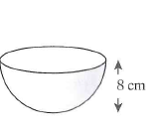

<_block>

[A] $134 cm³$

<_block>

[B] $584 cm³$

<_block>

[C] $986 cm³$

<_block>

[D] $1072 cm³$

<_block>

[D]